Name:___________________________ Period: _______ Date:___________
Living Environment
Human Reproduction
Male and Female Reproductive Systems
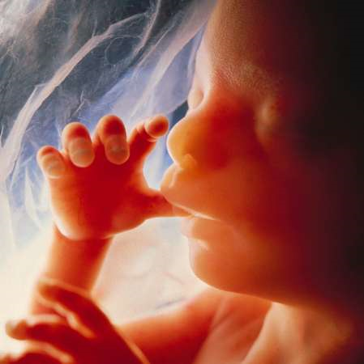
-After a few weeks of embryonic development,
humans begin to develop their primary sexual organs.

Male- Testes

The testes produce the hormone __________________.

Testosterone

- 1. Makes __________________________________________

■ 2. Develops ________________________________________

Female- Ovaries

A. The ovaries produce _____________ and _________________

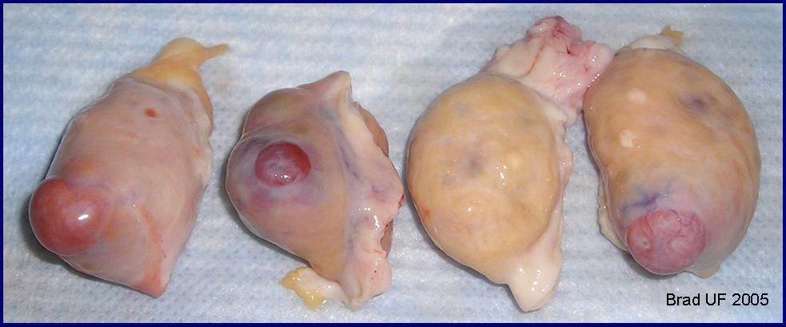

Female Hormones

1. Estrogen-__________________________________________________

__________________________________________________


2. Progesterone-________________________________

________________________________

Puberty

■ Period of rapid ________________________________

■ __________________________completely developed

■ Ages range from __________old for beginning of puberty

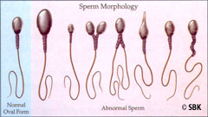
The Male Reproductive System

During puberty several traits become apparent

■ ________________________________________________

■ ________________________________________________

■ ________________________________________________

Label the Human Reproductive Organs
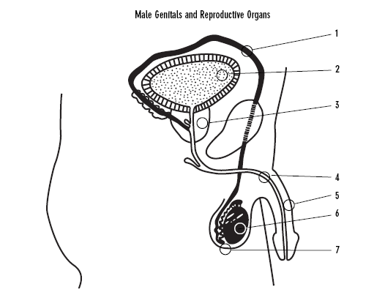



Major structures in the male reproductive system

1. Testes:
-_____________________________________________________
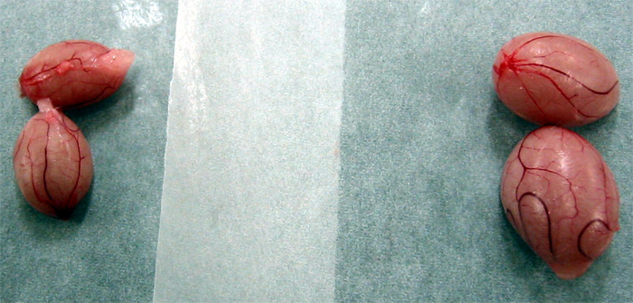
-Meiosis happens here forming haploid sperm

2. Epididymis: _______________________________________.

3. Vas Deferens: _________________________________________________.

Vasectomy: removal or tie up of the ____________________.

4. Urethra:

-_____________________________________________________

-This tube is used for both ________________________________

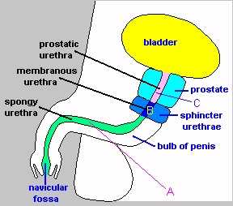
5. Penis: ______________________________________________

________________________________________________

Scrotum and temperature regulation

■ Scrotum ____________________________________________________

■ This is the _______________ for the testes

■ Sperm are best produced at a temperature at about _________________
-body temperature is higher than this
-scrotum will raise and lower the testes in order _______________

_____________________________________________________.

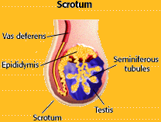
Sperm= _____________________________

■ Sperm cells have many _____________________.

Why?

a. sperm must swim a very long distance to reach the__________.
b. mitochondria supply the necessary _____________.

3. Head contains nucleus and enzymes necessary for fertilization

What is Semen?

-____________________________________________________.

Why do sperm need fluid to swim in?

■ a. It is enriched with ___________ to supply the sperm with energy

■ This fluid is produced by the _____________ in the male reproductive system
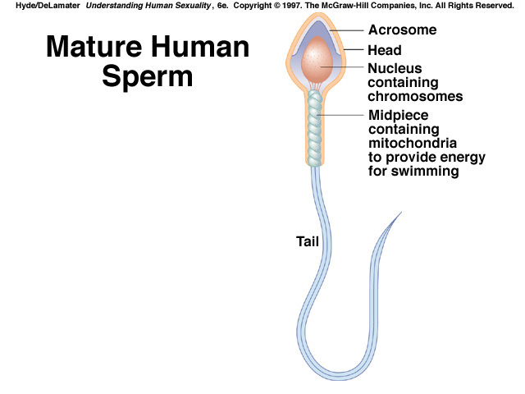

Cowper's gland, Seminal vesicle, prostate gland:

■ 3 lubricating glands

Prostate: ___________________________________________________

___________________________________________________

■ prostate cancer effects _______________________.
■ treated with radiation, estrogen, diet change, or by removing the gland

The Female Reproductive System Label the Diagram

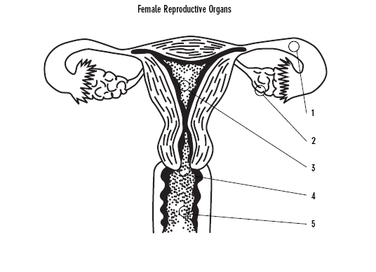



___________________ and ____________________ are the female reproductive hormones

Estrogen gives females __________________________________

Examples?

■ ____________________________________
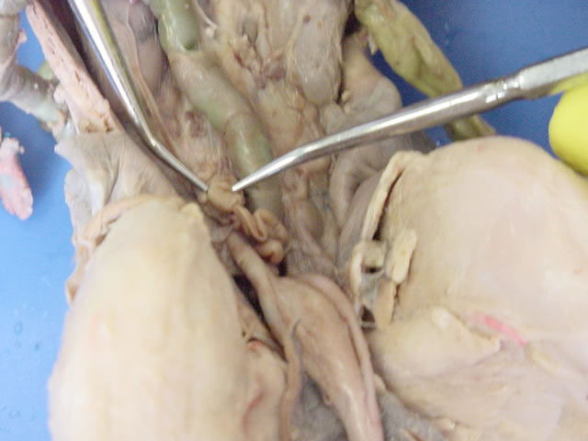
■ Widening of _________

The female reproductive system has 2 jobs

What are the 2 jobs?
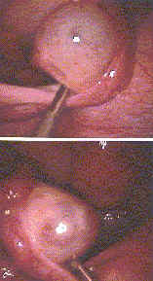
#1. _________________________________________

#2. __________________________________________

__________________________________________

Major female organs

Ovaries:

■ _________________________________________________

■ This is where eggs are produced and __________________

Fallopian Tubes or Oviducts:

■ These are tubes that carry the ______ from the _____ to the _______

■ This is where _____________________________
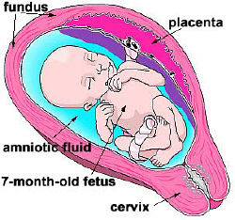
Uterus:

- Place _________________________
______________________________

 Pear shaped structure
that has a ___________________

Vagina:

■ Tube structure that leads from external environment to uterus

■ This is the tube that the _______________________

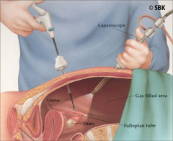
■ Is a ________________ environment that kills many sperm

Cervix: ___________________________________.

■ Cancer of the cervix is common
■ PAP smear detects

Infertility

Infertility is the lack of ability to _________________________

_____________________________________________________

Males
■ Can be due to a lack of __________ or low ________________
 Can be due to blockage or break of tubes to the urethra
Females
■ Failure to release _________________________

■ Blockage of ________________________

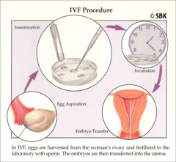
Treatments for Infertility

1. harvesting of eggs

■ “_______________________”
■ eggs are mixed with harvested sperm and fertilized
■ fertilized eggs are ________________ in the uterus
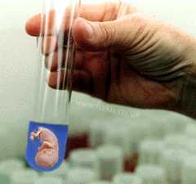
2. Surrogate mothering

■ embryos are implanted in _____________________

■ her uterus will care for the child

3. Hormone use
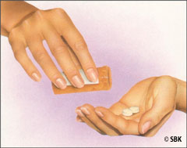
■ Increased levels of ______________________ can lead to conception

■ Stress can lead to infertility

Conclusion to Reproduction

Gestation period: __________________________________

Identical Twins: 1 egg/1 sperm
■ ______________________________.

Fraternal Twins: 2 eggs/2 sperm
- Like brothers and sisters (different DNA)

Sexually Transmitted Diseases

■ STDs are diseases, sometimes ________________, that are given by sexual contact

HIV

■ Deadly (Human Immunodeficiency Virus)

■ HIV has killed more than _________ million people since 1981

The Menstrual Cycle

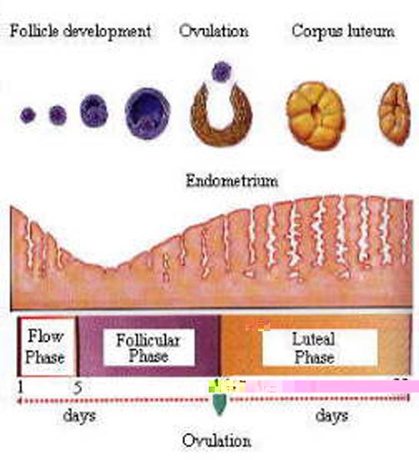
-Average cycle is _______________ but varies depending on the individual

4 Stages of the Menstrual Cycle

F O C M

Follicle stage, ovulation, corpus luteum stage, menstruation

Stage One: ________________________

-Estrogen levels _______________ which ______________ the lining of the uterus.
-These low levels stimulate the _______________ to release ___________________________________________ (FSH)
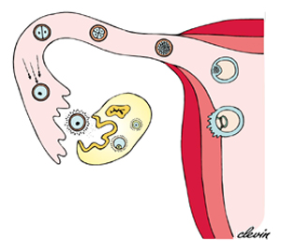
-Stage lasts about 10 days

Stage Two: _________________________

-At day 14, ___________________________________________
-Huge increases in _________________ cause the follicle to burst open and release the egg.

Stage Three: ____________________________

-10 to 14 days long
-The remaining follicle turns yellow and __________________ __________________________________________________.
-This increase in hormone levels thickens the uterine lining even more
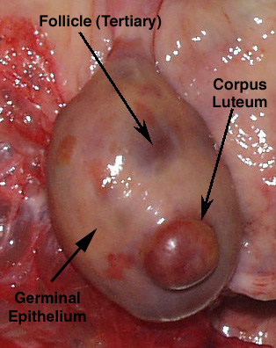
-A female has the best chance of getting pregnant during the first _______________ of this stage.

Stage Four: _____________________

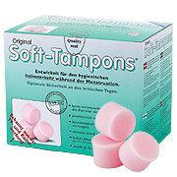
-5 to 6 days long
-Happens only if ______________________________________.
-Egg will pass through the uterus without implementation.
-____________________________________ levels decrease.
-This decrease in hormone level cause the uterine lining to detach from the uterine wall.
-This tissue, along with blood and the unfertilized egg, are _____________________________________________.

-What is Menopause?_____________________________________

HUMAN REPRODUCTIVE SYSTEMS: LABEL ME!
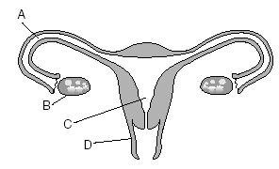

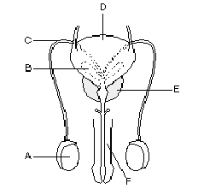

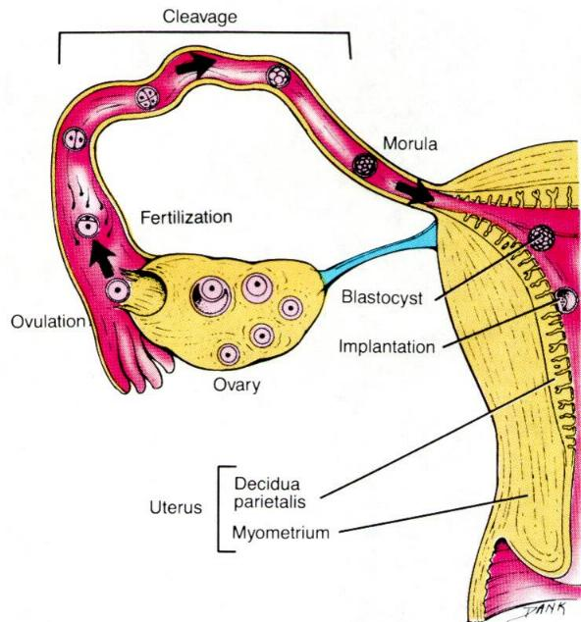
Menstrual Cycle

4 Stages of the Menstrual Cycle


