What are the CELL BOUNDARIES?

ALL cells have: ____________________

Some cells have, like plants have: ______________________

The Cell Membrane: aka.

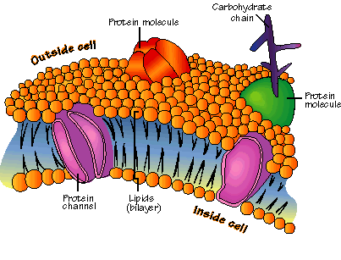
FUNCTION:

FUNCTION:

THE phosphoLIPID BILAYER:
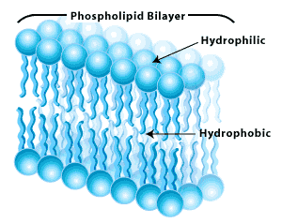
FUNCTION:

Hydrophilic:

Hydrophobic:

THE CELL WALL:

Is found in:

Is porous, meaning:

FUNCTION:

MADE From:

- A polysaccharide called:::
- Where can you find cellulose in the room?

WHAT Is DIFFUSION?

When does diffusion occur?

THINKING CONCENTRATION: the mass of the solute in a given volume of solution, or mass/volume.

Example: If you dissolved 12 grams of salt in 3 liters of water, the concentration would be 12g/3L or 4g/L

Example: What would be the concentration if you had 12 grams of sale in 6 liters of water?

NOW thinking PERCENT concentration:

Question 1: If a solution is 10 % salt, what percentage of the solution is water?

Salt SUCKS

Question 2: This cell’s cytoplasm is 95% water. How much is the dissolved stuff?

The cell is placed in a 10% salt solution. So how much is water?

What happens to the cell?
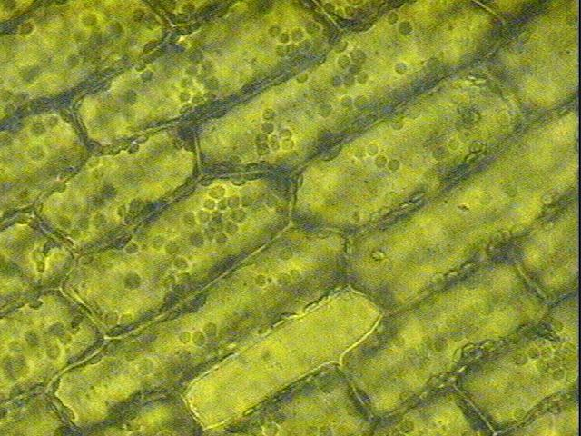
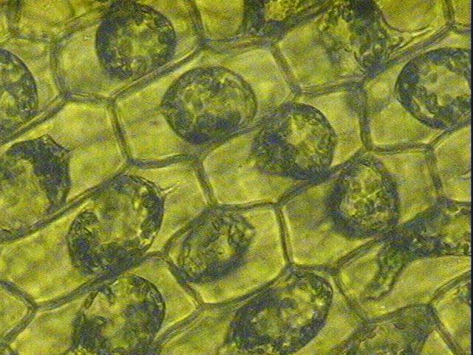

DIFFUSION PROBLEMS:

Step 1:

Step 2:
Just a Reminder:

What does it mean to be permeable?

What does it mean to be impermeable?

What does it mean to be selectively permeable?

Provide an example of a selectively permeable membrane: ____________________________

Have you ever learned by __________________? (Passive Transport)

Osmosis is:

*

*

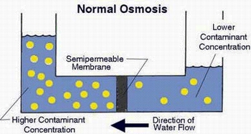

A few IMPORTANT terms:

Isotonic:

Hypertonic:
Hypotonic:

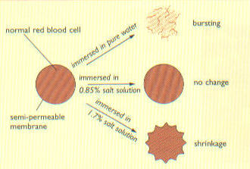

Lend a Helping Hand:

Molecules move from an area of ________________________ to an area of ______________________________.

Does facilitated diffusion require energy?

What facilitates the movement of molecules?

Provide a REAL Life example:

Active Transport:

Requires _____________________ because the movement of molecules is from an area of _____________________ to an area of _______________________

Kind of like when you are PUSHING your way through the PIT to make it to Living Environment class on TIME!!

A Few Examples of AT:
Endocytosis:

Phagocytosis:

Pinotcytosis:

Exocytosis:



